**DOCKER COMMANDS AND EXPLANATION**

**1. docker –version**

This command is used to get the currently installed version of docker

**Screenshot:**

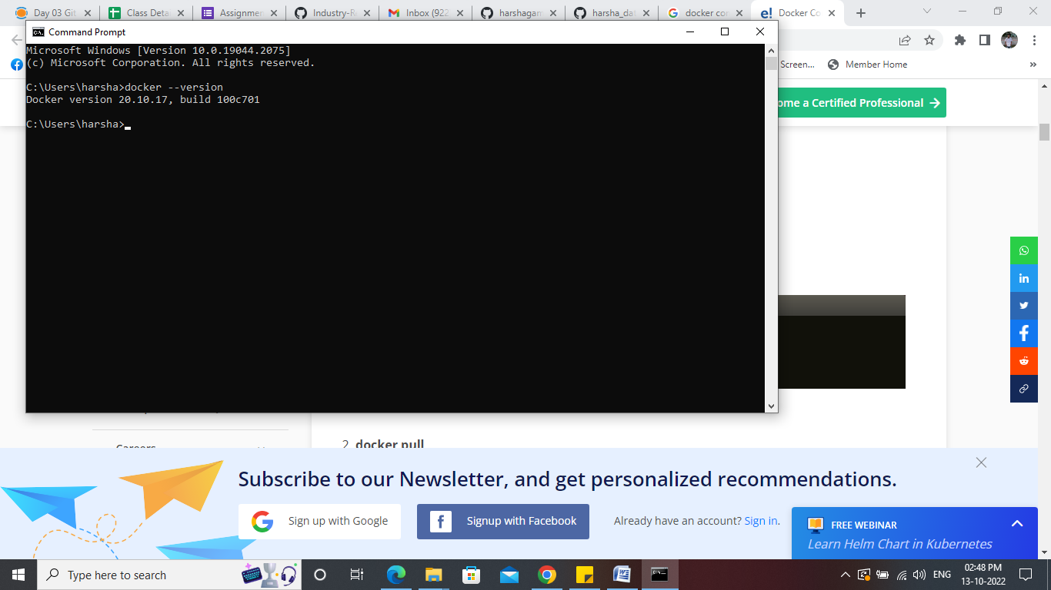

**2.** **docker pull**

This command is used to pull images from the **docker repository**(hub.docker.com)

**Screenshot:**

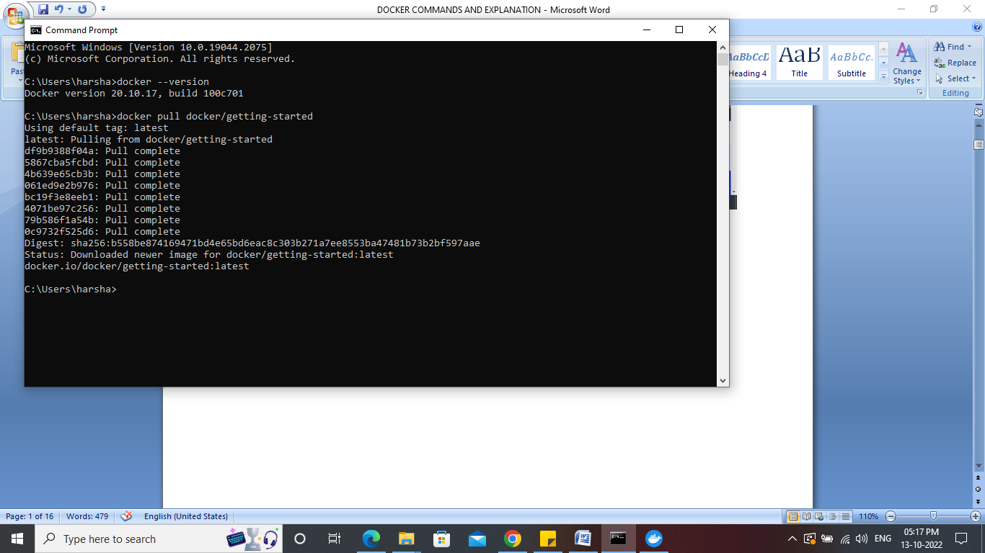

**3. docker images**

The status command is used to display the all the docker images available in our local system **Screenshot:**

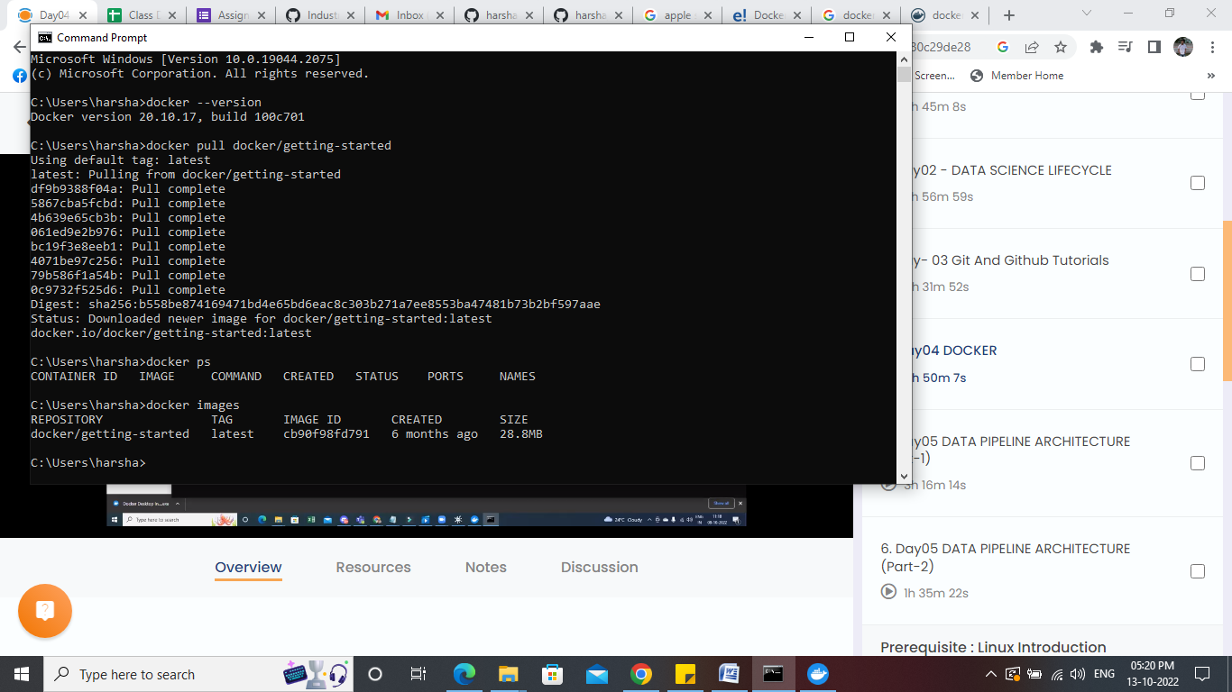

**4. docker run**

This command is used to create a container from an image

**Screenshot:**

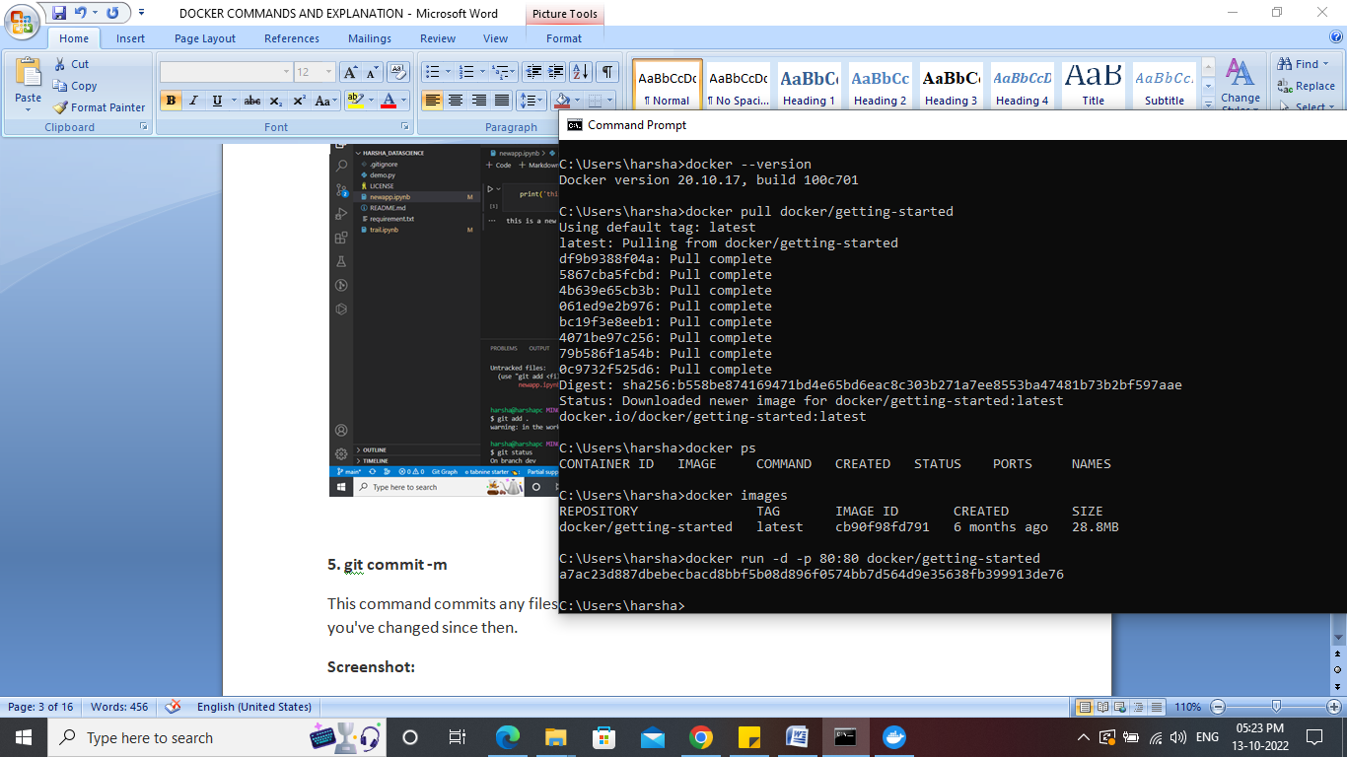

**5.docker ps**

This command is used to list the running containers

**Screenshot:**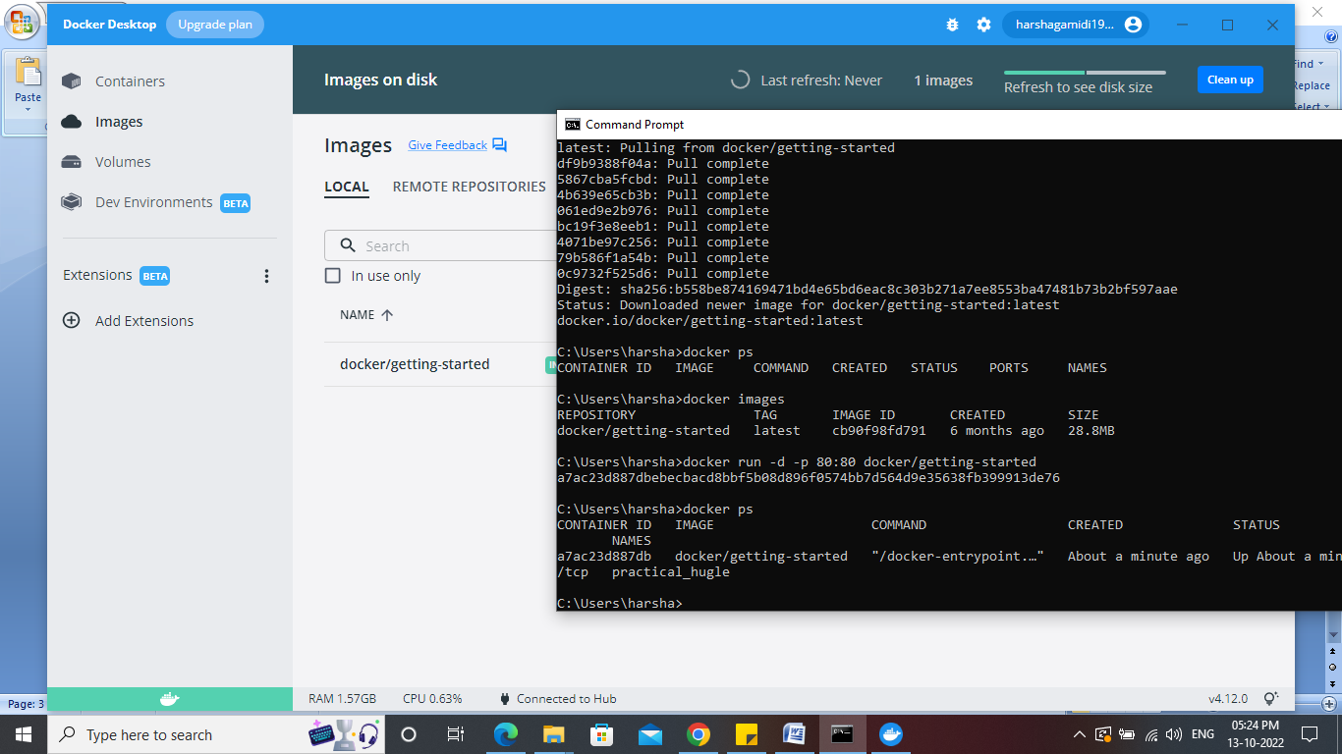

**6. docker stop**

This command is used to stop the containers using the container id which are available in our local system

**Screenshot:**

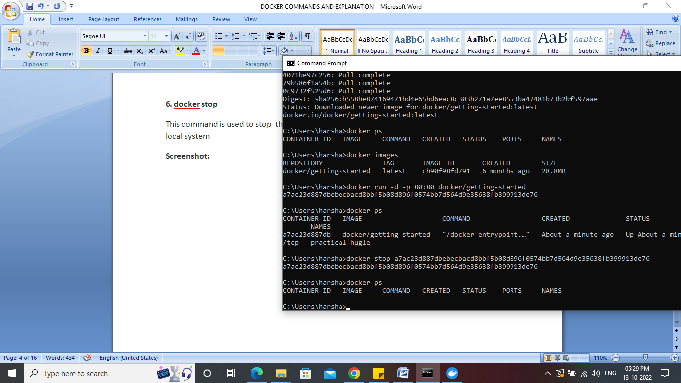

**7.** **docker kill**

This command kills the container by stopping its execution immediately. The difference between ‘docker kill’ and ‘docker stop’ is that ‘docker stop’ gives the container time to shutdown gracefully, in situations when it is taking too much time for getting the container to stop, one can opt to kill it

**Screenshot:**

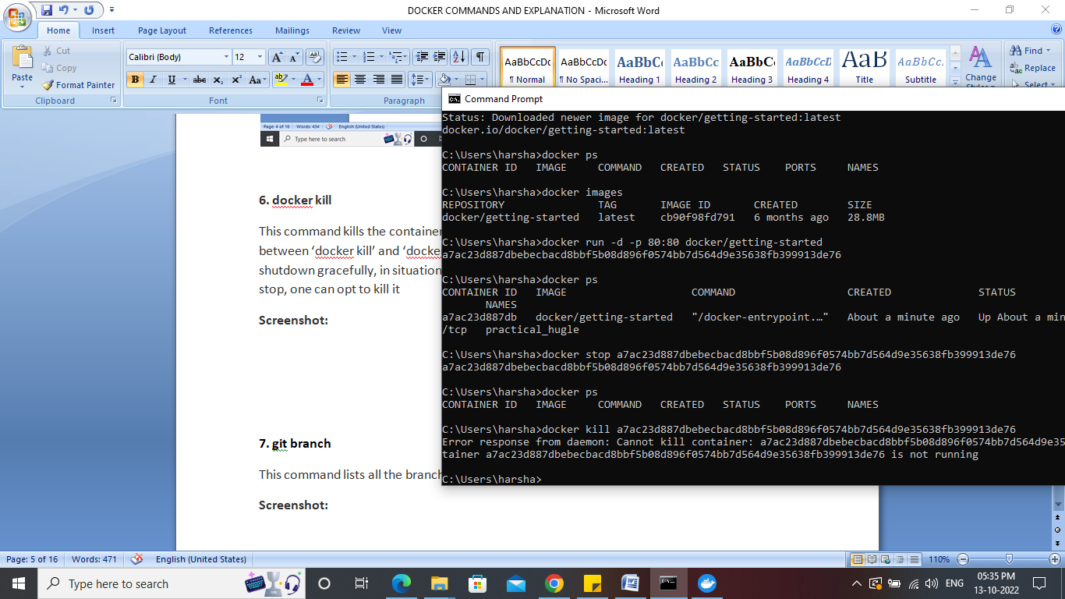

**8. docker ps -a**

This command is used to show all the running and exited containers

**Screenshot:**

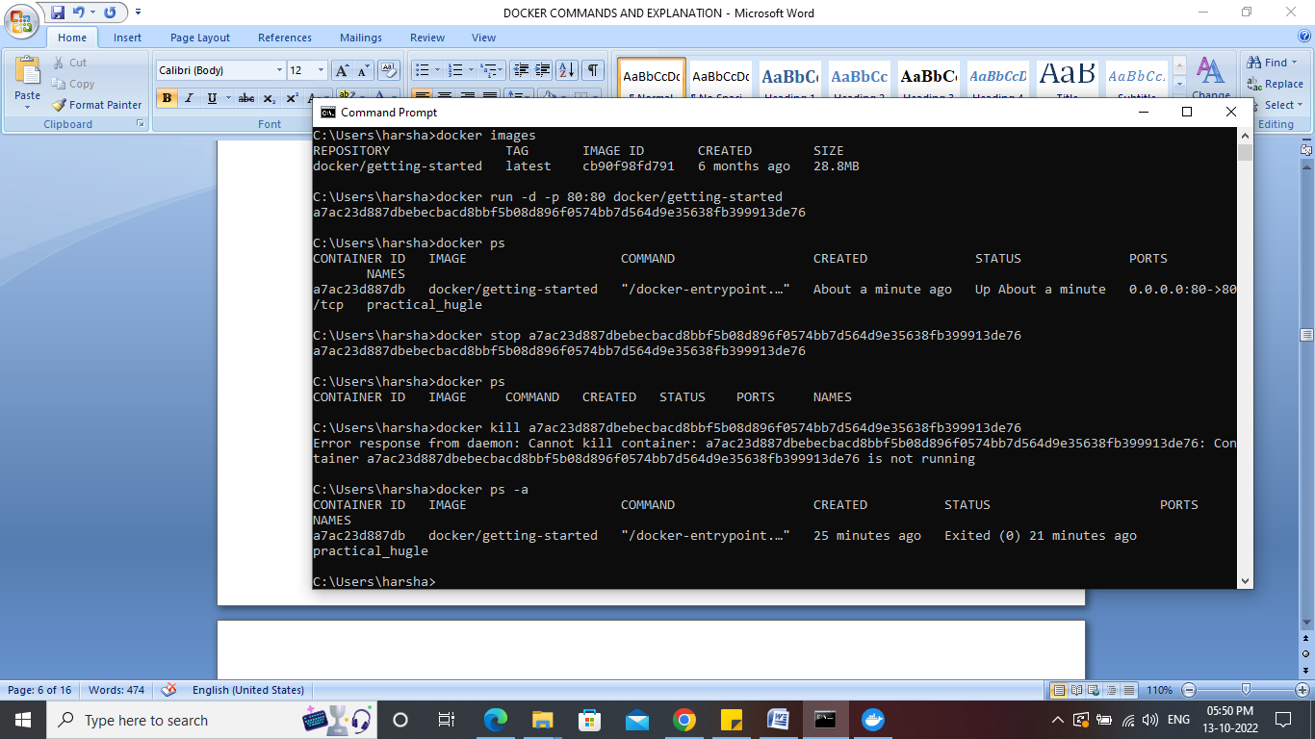

**9.docker login**

This command is used to login to the docker hub repository

**Screenshot:**

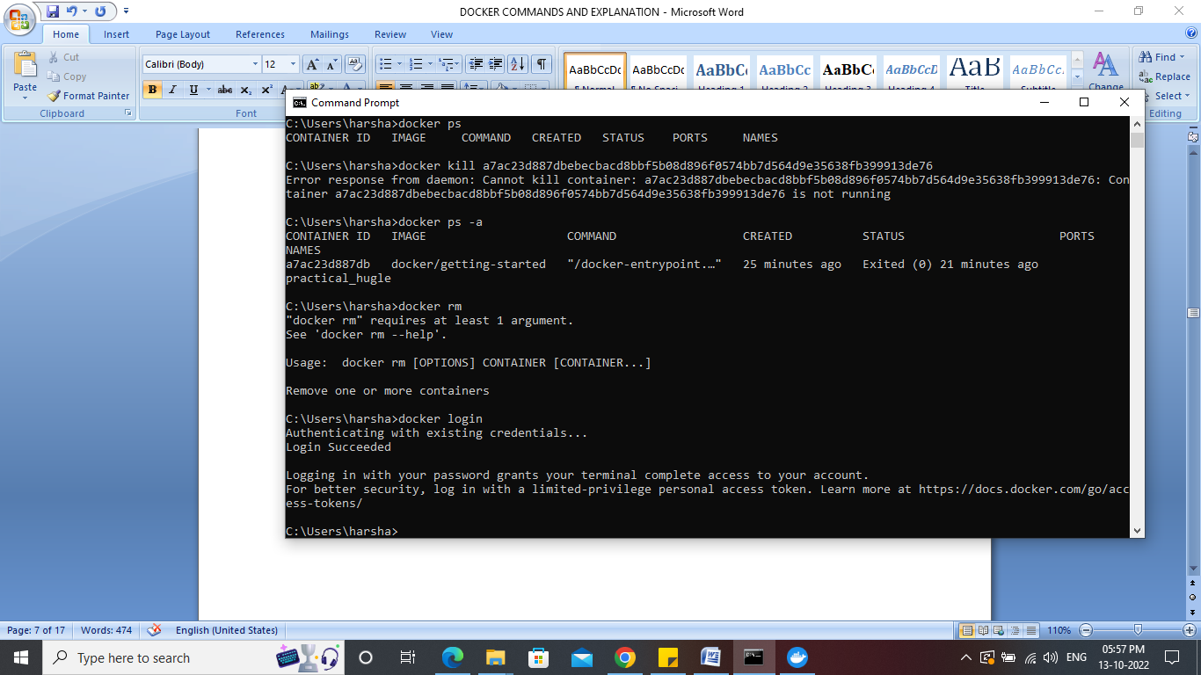

**10.docker build**

This command is used to build an image from a specified docker file

**Screenshot:**

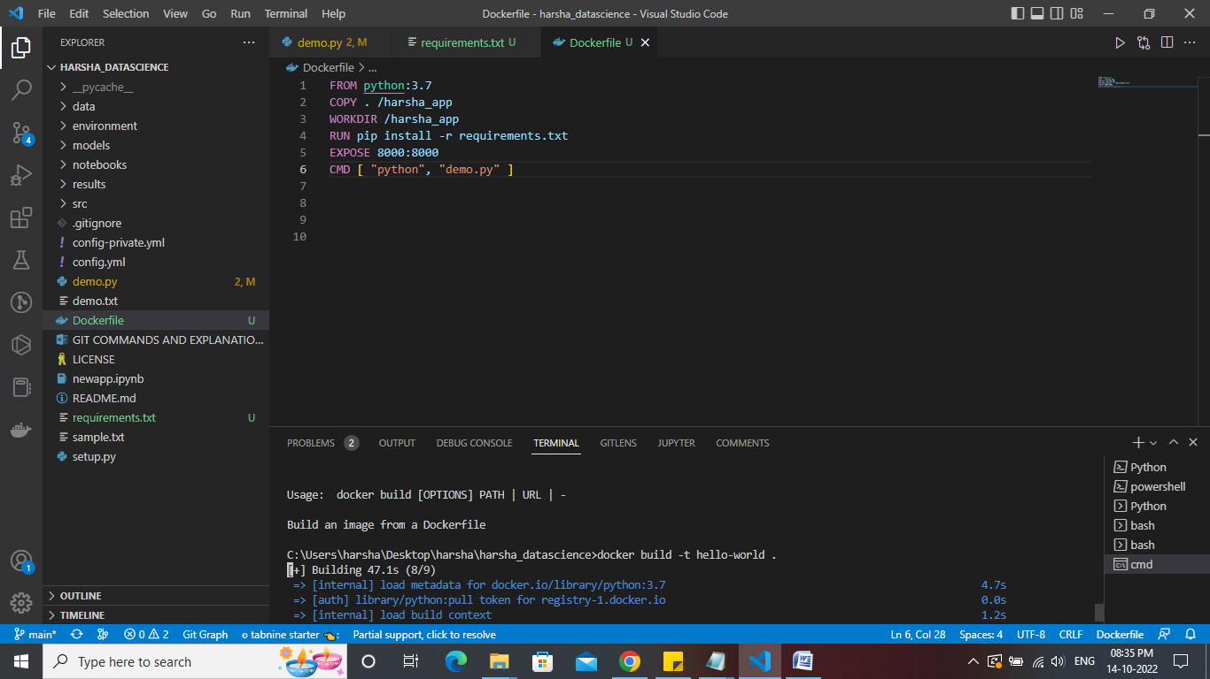

**11. docker rmi**

This command is used to delete an image from local storage

**Screenshot:**

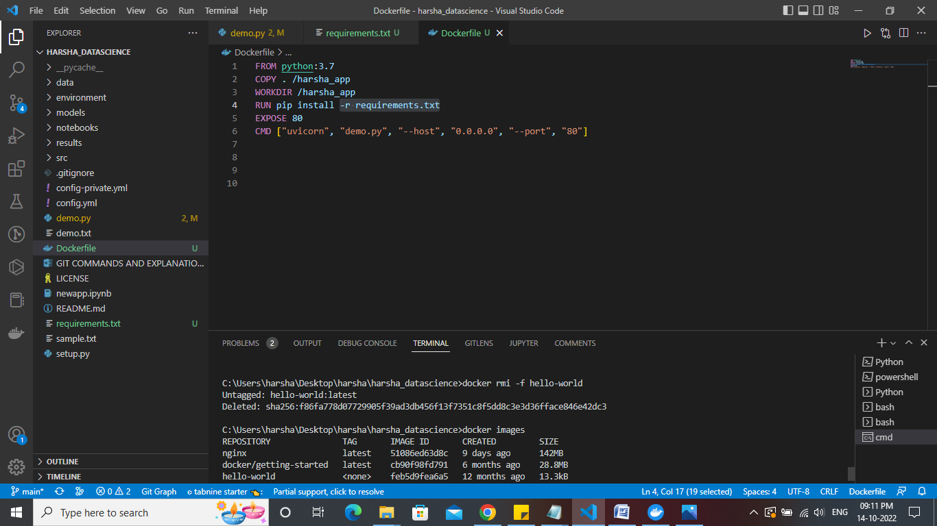

**12.docker push**

This command is used to push an image to the docker hub repository

**Screenshot:**

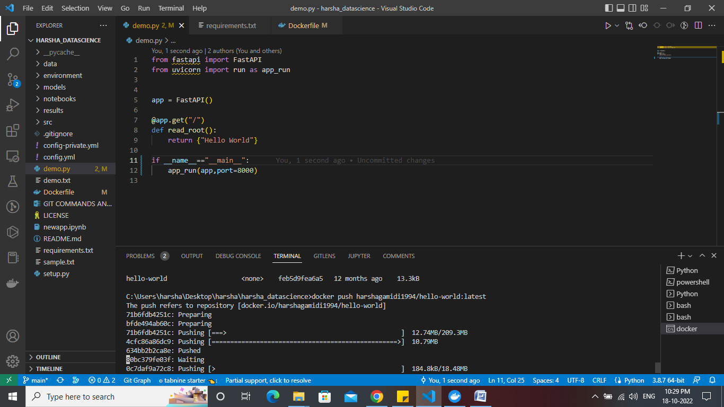

**13.** **docker rm**

This command will delete the stopped containers

**Screenshot:**

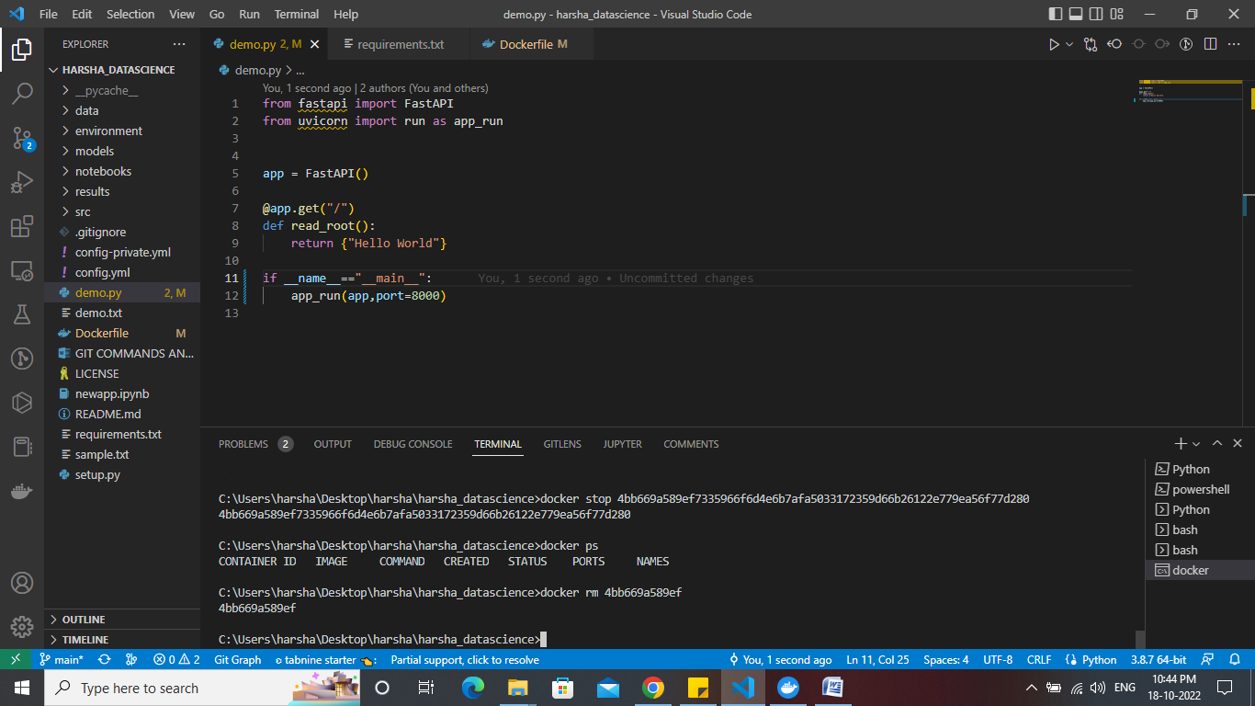

**14.docker exec**

This command is used to access the running container

**Screenshot:**

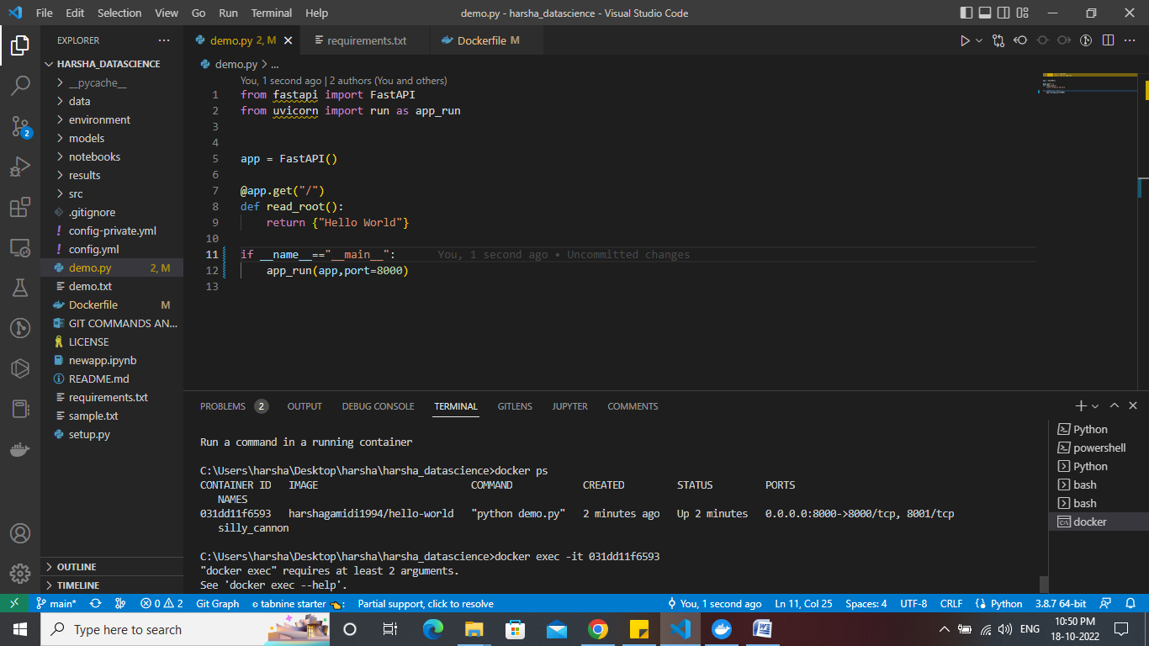

**15. docker info**

Display system-wide information

**Screenshot:**

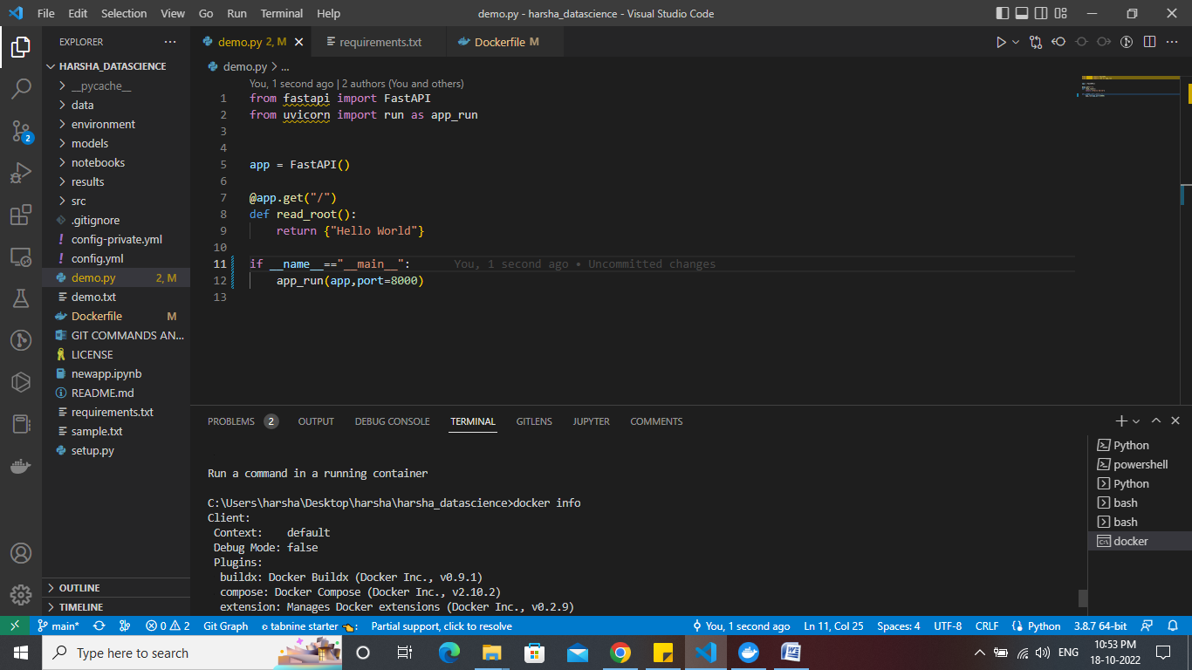

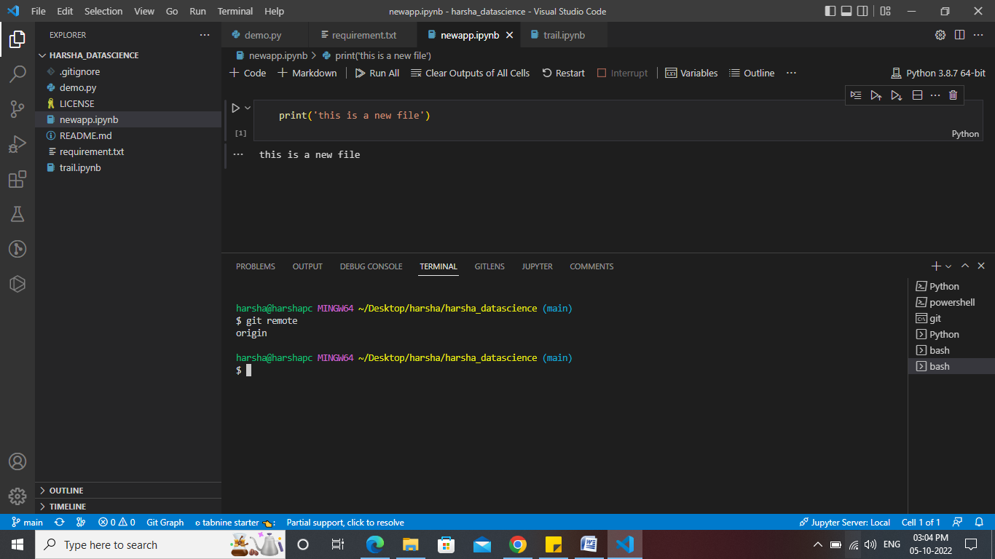

**15. git remote --v**

If a repository contains more than one remote connection, this command will list them all.

**Screenshot:**

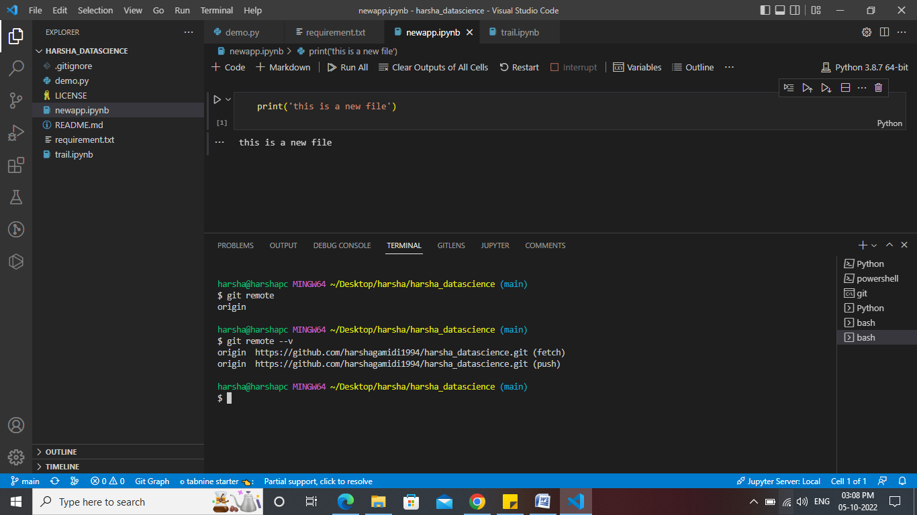

**16.** **git push --set-upstream origin master**

This command will set the selected branch as the default remote branch.

**Screenshot:**

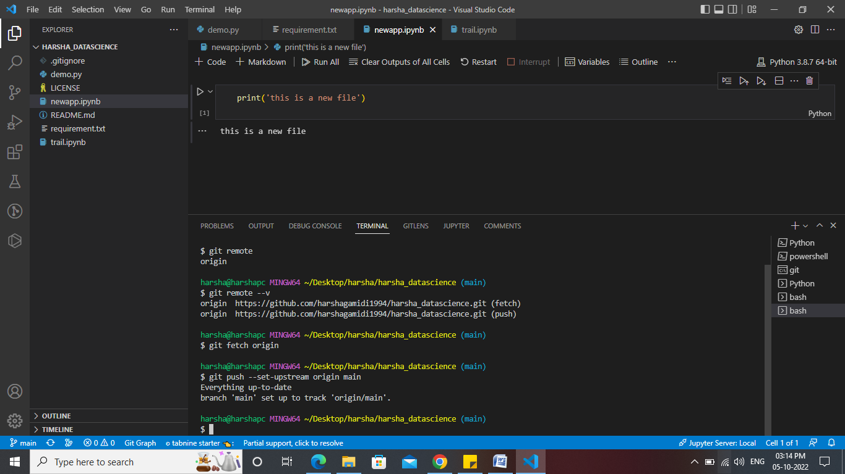

**17.git branch –vv**

It will list out the all the branches and will highlight the default branch

**Screenshot:**

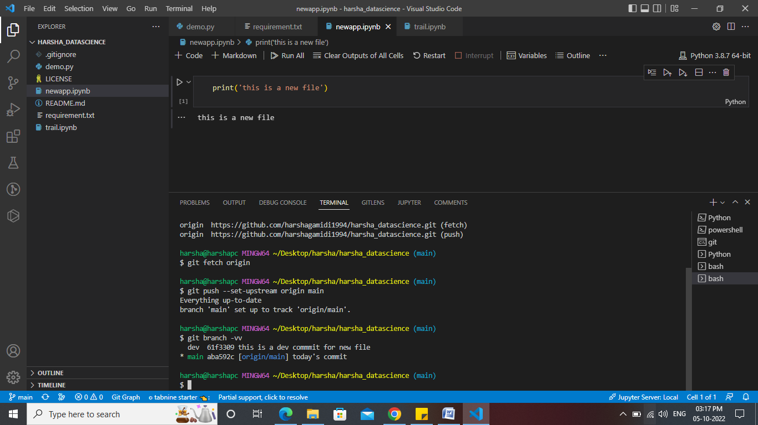

**18. git stash**

This enables you to switch branches without committing the current branch and takes your uncommitted changes (both staged and unstaged), saves them away for later use, and then reverts them from your working copy.

**Screenshot:**

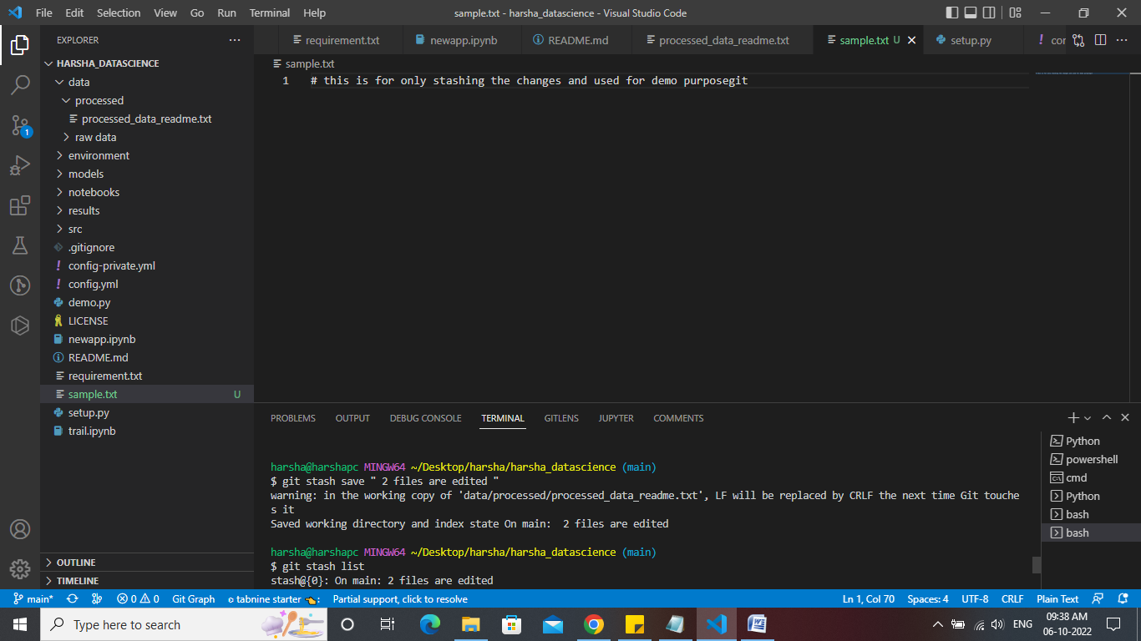

**19. git stash list**

This command helps us to get the list of the stashed files in the below order mentioned in the screenshot

**Screenshot:**

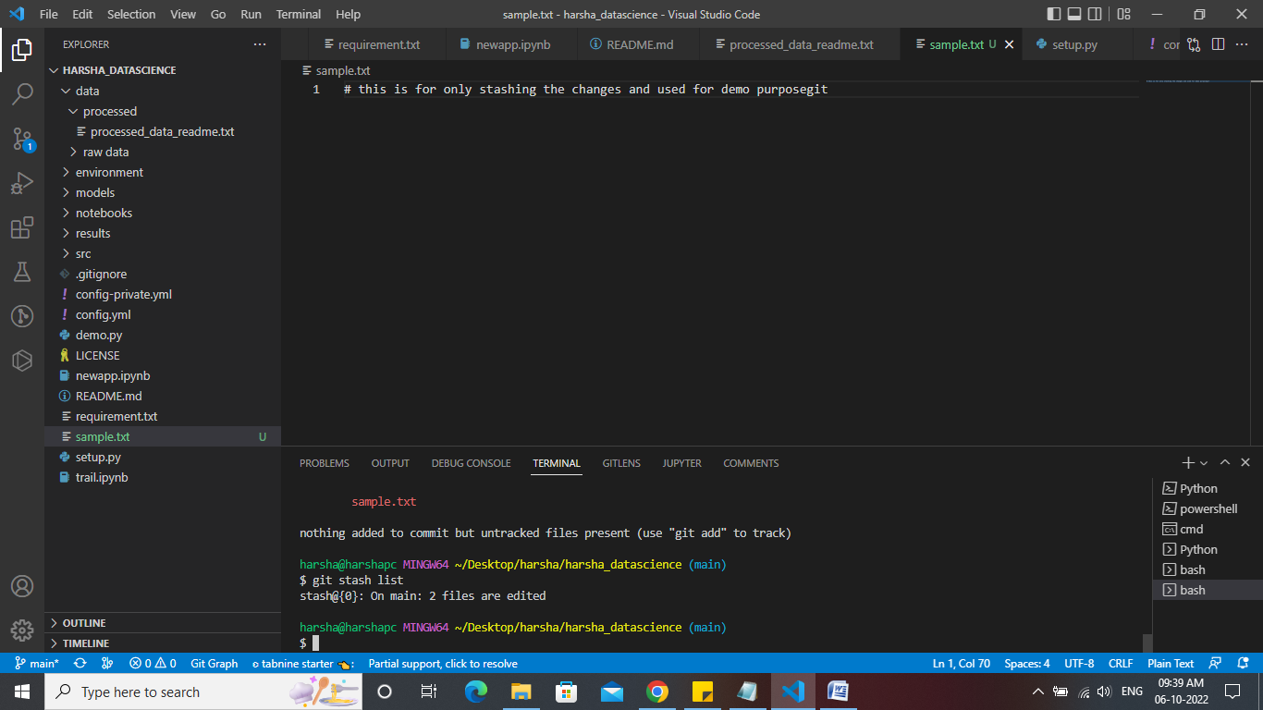

**Stash changes**

